

PROJECT TITLE |  |  | STUDENT SOCIAL MEDIA AND MENTAL HEATH ANALYTICS DASHBOARD
PROJECT CATEGORY |  |  | Education Analytics  Mental Health Analytics  Behaviour Analytics  Country Analytics
INSTITUTE NAME |  |  | Infinity Code Nexus
TRAINER / GUIDE |  |  | Anand Kumar Anamaina
CREATED BY |  |  | INJEETI LAHARI
TOOLS USED |  |  | Power BI Desktop Power Query, DAX & Power BI  Service
SUBMISSION DATE |  |  | [10/06/2026]
  PROJECT OVERVIEW

Prepared as part of the Power BI Masterclass Program to demonstrate skills in Data Analysis, Data Modeling, DAX Development, Dashboard Design, UI/UX, Storytelling, and Business Intelligence Reporting.

PROJECT OBJECTIVE

Develop a comprehensive Power BI dashboard to analyze how social media usage affects mental health among students globally, covering stress levels, platform behaviour, lifestyle habits, and geographical trends.

Participants are expected to:
- Analyze student stress levels and mental health scores
- Evaluate social media platform usage patterns
- Understand lifestyle factors such as sleep and study hours
- Analyze physical activity and its relation to wellbeing
- Assess mental health trends across countries and demographics ✔ Generate actionable business and academic insights

PROJECT GOAL

Transform student lifestyle and social media data into actionable insights that help educators, researchers, and institutions understand the relationship between digital habits and student mental wellbeing.

BUSINESS PROBLEM

Educational institutions and researchers need to understand how social media habits, sleep patterns, study hours, and physical activity influence student mental health and stress levels.

The objective is to identify:
- Which social media platforms are most commonly used by students?
- Does higher social media usage correlate with lower mental health scores?
- How do stress levels vary across academic levels and genders?
- Which countries show the highest and lowest average mental health scores?
- How do lifestyle factors like sleep and physical activity affect wellbeing?

BUSINESS QUESTIONS

Participants must answer:
- What is the average mental health score across all students?
- Which platform is most used and how does it relate to mental health?
- How does academic level affect stress and mental health?
- Which countries have the highest and lowest mental health scores?
- What is the most common purpose of social media use?
- How do sleep hours vary across genders and academic levels?
- What percentage of students fall in the Very High stress category?

DATASET INFORMATION

DATASET NAME | Student Mental Health & Social Media Usage Dataset
TOTAL RECORDS | 5,000 Students
TOTAL COUNTRIES | 111
KEY COLUMNS | Student_ID, Country, Gender, Academic_Level,  Most_Used_Platform, Purpose_Of_Use,  Avg_Daily_Usage, Mental_Health_Score, Stress_Level,  Stress_Category, Study_Hours, Sleep_Hours,  Physical_Category, Daily_Unlocks

EXPECTED ANALYSIS AREAS

- Social Media Analytics
- Mental Health Analytics
- Lifestyle Analytics
- Country Analytics
- Demographic Analytics
- Drill-through Detail Analytics

POWER QUERY TRANSFORMATIONS

DATA CLEANING ACTIVITIES

- Removed Duplicate Records
- Validated Mental Health Score and Stress Level ranges
- Handled Missing Values
- Corrected Data Types
- Standardized Category Labels (Stress_Category, Physical_Category)

DATA PREPARATION ACTIVITIES

- Renamed Columns for readability
- Created Custom Columns (Stress_Category, Physical_Category)
- Replaced Values for consistency ✔ Removed Unnecessary Columns
- Filtered invalid or out-of-range entries

CUSTOM COLUMNS CREATED

Stress Category
Sleep Category
Usage Category
Study Hour Group
Health Category
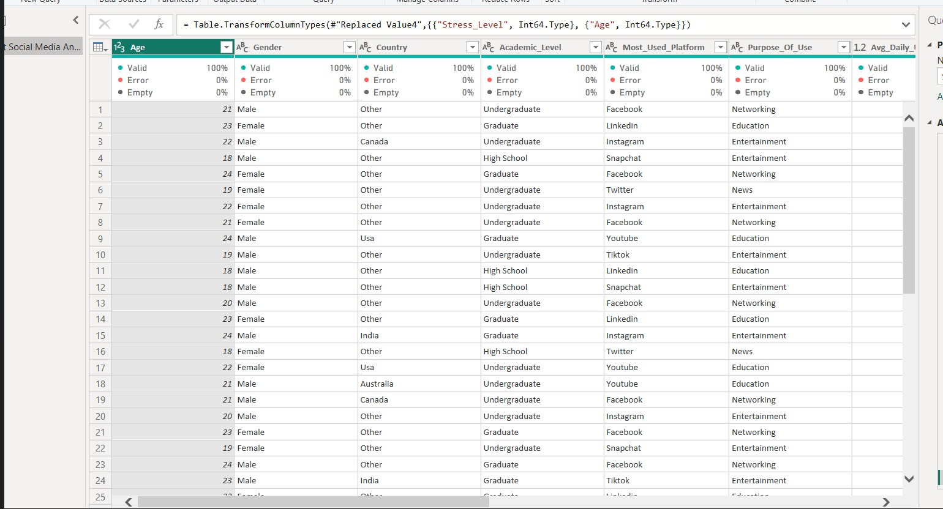

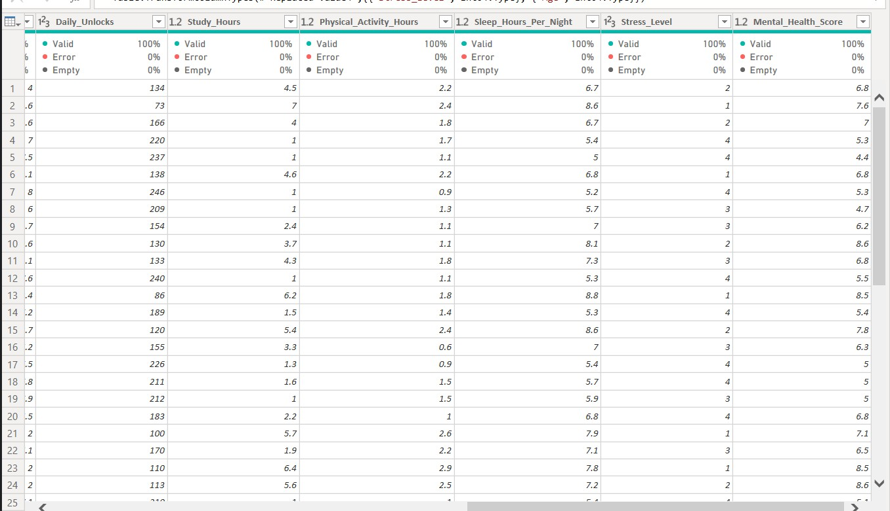

DAX MEASURES USED

TOTAL STUDENTS | COUNTROWS(Student_Table) Purpose: Calculate total student count.
AVG MENTAL HEALTH | AVERAGE(Student_Table[Mental_Health_Score]) Purpose: Calculate average mental health score.
AVG STRESS LEVEL | AVERAGE(Student_Table[Stress_Level]) Purpose: Calculate average stress level.
AVG DAILY USAGE | AVERAGE(Student_Table[Avg_Daily_Usage]) Purpose: Calculate average daily social media usage.
AVG SLEEP HOURS | AVERAGE(Student_Table[Sleep_Hours]) Purpose: Calculate average nightly sleep hours.
AVG STUDY HOURS | AVERAGE(Student_Table[Study_Hours]) Purpose: Calculate average daily study hours.
TOTAL COUNTRIES | DISTINCTCOUNT(Student_Table[Country]) Purpose: Count distinct countries in the dataset.
AVG DAILY UNLOCKS | AVERAGE(Student_Table[Daily_Unlocks]) Purpose: Calculate average daily phone unlocks.

VISUALIZATIONS USED

KPI CARDS | Display key metrics: Total Students, Avg Mental  Health Score, Avg Stress Level, Avg Daily Usage, Avg Study Hours, Avg Sleep Hours, Total Countries, Avg Daily Unlocks.
DONUT CHART | Show distribution of Stress Categories and Platform usage share.
HORIZONTAL BAR CHART | Compare mental health scores by country, gender, academic level and platform usage.
LINE CHART | Show Avg Mental Health Score trend across all 111 countries and sleep hours by academic level & gender.
SCATTER CHART | Analyze Platform Usage vs Mental Health Score across platforms.
DATA TABLE | Country-wise breakdown of Avg Mental Health, Avg Daily Usage, Avg Stress Level, Total Students.
SLICERS | Interactive filters for Platform, Gender, Country, Academic Level.

DASHBOARD SCREENSHOTS

PAGE 1 — EXECUTIVE OVERVIEW
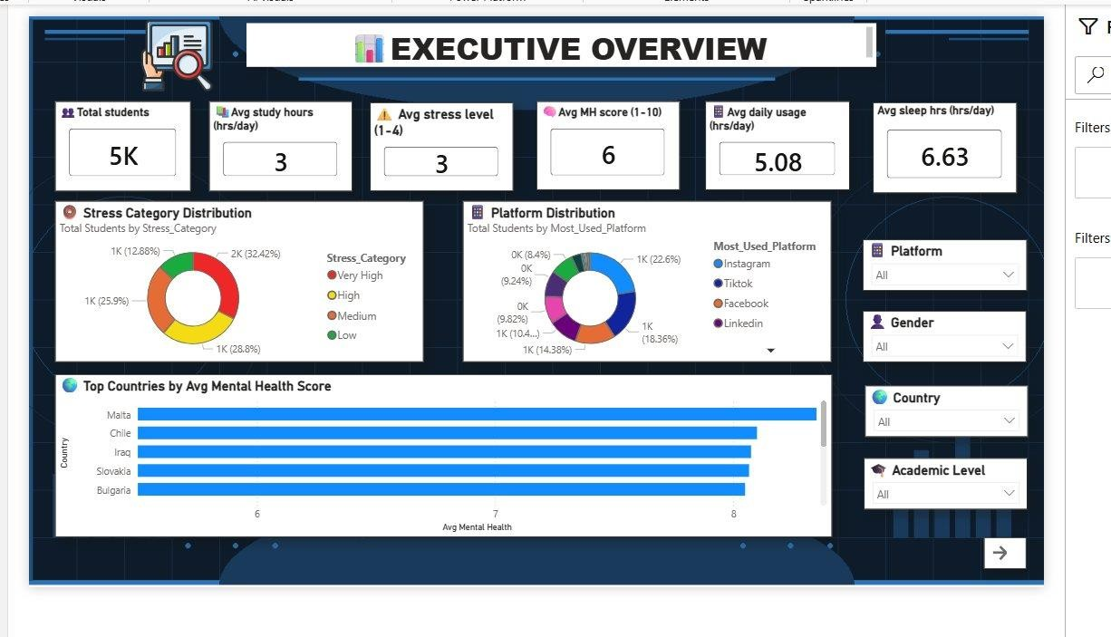

Provides a high-level summary of all key metrics. KPI cards show Total Students (5K), Avg
Stress Level (3/4), Avg Mental Health Score (6/10), Avg Daily Usage (5.08 hrs/day), and Avg Sleep Hours (6.63 hrs/day). Includes Stress Category Distribution donut, Platform Distribution donut, and Top Countries by Avg Mental Health Score bar chart.

PAGE 2 — SOCIAL MEDIA ANALYTICS
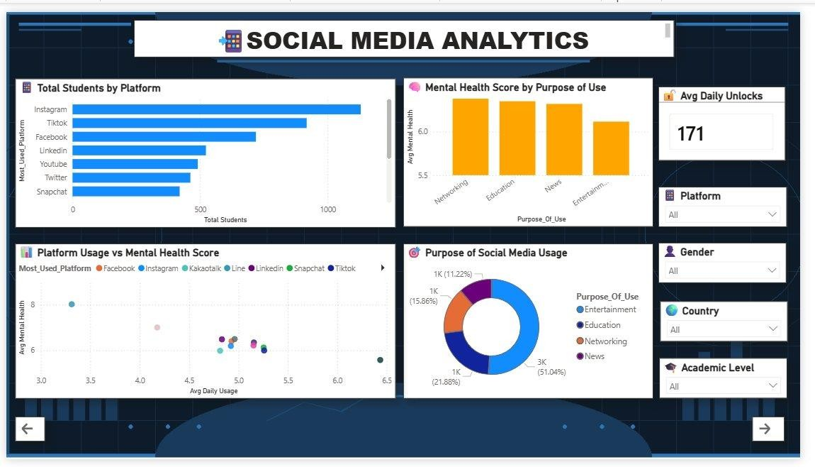
Analyzes platform-level behaviour and its link to mental health. Instagram leads usage with 1,000+ students. Entertainment dominates purpose of use at 51%. Students using social media for Networking and Education report higher mental health scores. Avg Daily Unlocks: 171.

PAGE 3 MENTAL HEALTH ANALYTICS
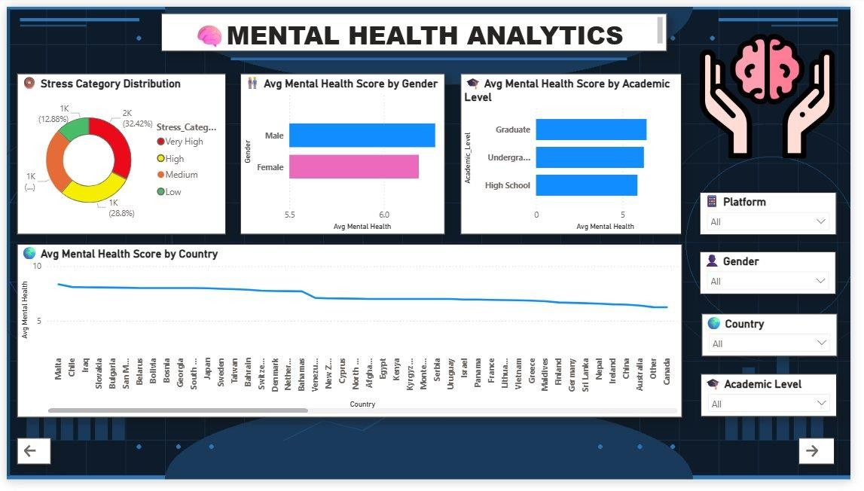
Focuses on mental health segmented by stress category, gender, academic level, and country. Graduate students score highest (~6.2). Males marginally outperform females. Malta leads globally with ~9.5, showing a declining trend across all 111 countries.

PAGE 4 LIFESTYLE ANALYTICS
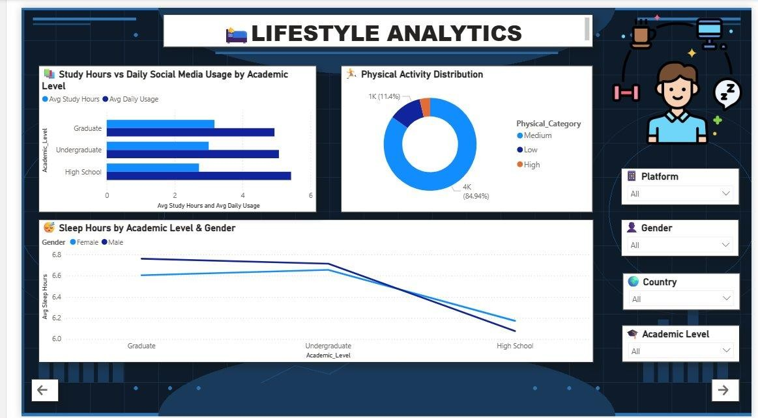
Examines study hours vs social media usage, physical activity distribution (85% Medium), and sleep hours by academic level and gender. High school students sleep least and study least. Sleep declines from Graduate to High School across both genders.

PAGE 5 COUNTRY ANALYTICS
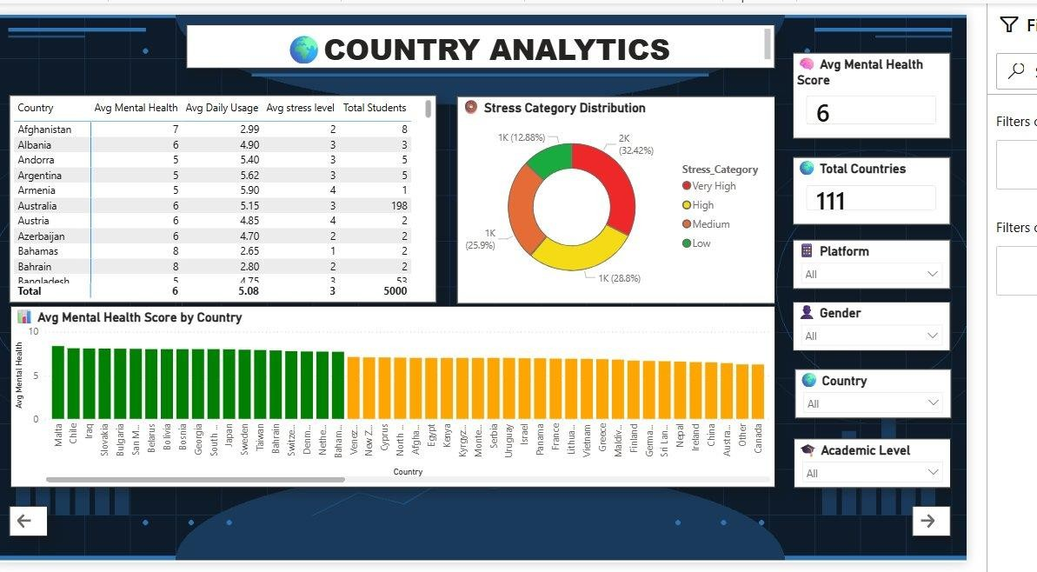

Global comparison across 111 countries. Includes a data table with Avg Mental Health, Avg Daily Usage, Avg Stress Level and Total Students per country, a Stress Category donut, and a colour-coded bar chart (green = high mental health, orange = lower). Supports drill-through to Page 6.

PAGE 6 COUNTRY DETAIL ANALYSIS (DRILL-THROUGH)
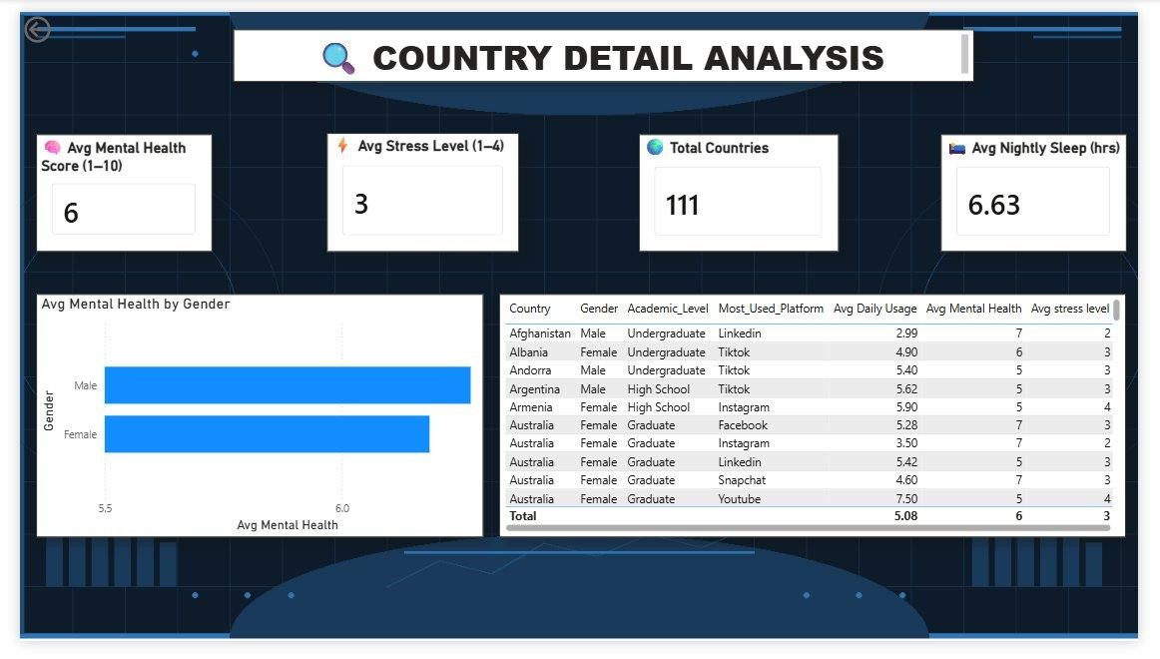
Drill-through destination from Page 5. Displays KPI cards for Avg Mental Health Score (6), Avg Stress Level (3), Total Countries (111), and Avg Nightly Sleep (6.63 hrs). Includes Avg Mental Health by Gender bar chart and a detailed row-level data table.

KEY INSIGHTS
INSIGHT 1 | Over 60% of students fall in High or Very High stress categories, indicating a widespread mental health challenge.
INSIGHT 2 | Instagram and TikTok together account for over 40% of most-used platform share among students.
INSIGHT 3 | Entertainment-driven social media use (51%) correlates with the lowest mental health scores.
INSIGHT 4 | Countries with lower average daily usage (e.g., Afghanistan at 2.99 hrs/day) report higher mental health scores.
INSIGHT 5 | Graduate students consistently report the best mental health and sleep outcomes; high school students the worst.
INSIGHT 6 | There is significant global disparity — Malta (~9.5) vs lower-scoring nations below 6.
INSIGHT 7 | 84.94% of students have Medium physical activity, suggesting limited high-intensity exercise routines.

BUSINESS RECOMMENDATIONS

RECOMMENDATION  1 | Introduce digital wellness programs to reduce entertainment-based social media usage among students.
RECOMMENDATION  2 | Promote purposeful social media use (education, networking) as it correlates with better mental health outcomes.
RECOMMENDATION  3 | Increase awareness of sleep hygiene, especially for high school students who show the lowest sleep averages.
RECOMMENDATION  4 | Encourage physical activity programs in academic institutions to improve overall student wellbeing.
RECOMMENDATION  5 | Provide targeted mental health support for students in countries with below-average mental health scores.

FEATURES IMPLEMENTED
- Drill-through (Country Analytics → Country Detail Analysis)
- Interactive Slicers (Platform, Gender, Country, Academic Level)
- Navigation Buttons (Arrow buttons across all 6 pages)
- KPI Cards with emoji-labelled titles
- Conditional Formatting (colour-coded bar chart on Country Analytics)
- Custom Background Theme (dark navy Power BI background)
- Cross-page Filter Consistency
- Responsive Donut, Bar, Line, and Scatter visuals

CHALLENGES FACED
Data Cleaning | Standardizing stress and physical activity categories across inconsistent raw data entries.
Drill-through Setup | Configuring the drill-through filter correctly from Country Analytics to Country Detail Analysis.
Dashboard Layout | Balancing visual density across pages while maintaining a clean, readable design.
Background Design | Creating and applying a custom PNG background image that renders correctly in Power BI.
KPI Card Sizing | Ensuring consistent KPI card sizing across all pages including the drill-through page.

LEARNINGS
- Power Query data cleaning and transformation
- DAX measure development for KPIs and aggregations
- Dashboard design and UI/UX layout principles
- Drill-through and navigation implementation in Power BI
- Conditional formatting for data storytelling
- Custom background design and theme application
- Business analysis and insight generation from student data

PROJECT STORYTELLING

BUSINESS SCENARIO

Educational institutions and researchers globally are increasingly concerned about the mental health of students. With the rise of social media platforms, understanding how digital habits affect student wellbeing has become critical. This dashboard transforms raw student data into a compelling story of stress, sleep, usage patterns, and mental health outcomes across 111 countries.

ANALYSIS APPROACH

- Analyzed mental health scores across platforms, genders, academic levels, and countries.
- Compared stress categories and identified dominant stress groups.
- Evaluated the relationship between daily social media usage and mental health scores.
- Examined lifestyle factors (sleep, study hours, physical activity) and their impact on wellbeing.
- Used drill-through for granular country-level investigation.

KEY FINDINGS

- Students using social media primarily for entertainment report the lowest mental health scores.
- Graduate students maintain better mental health and sleep patterns than high school students.
- Countries with lower daily social media usage tend to report higher mental health scores.
- Very High stress is the most prevalent category, affecting over 32% of all students.
- Instagram is the dominant platform, used by the highest number of students globally.

BUSINESS IMPACT

- Supports student mental health awareness programs.
- Enables data-driven policy decisions in educational institutions.

- Highlights at-risk student groups for targeted interventions.
- Provides geographic insights for international mental health initiatives.
- Enables better academic and lifestyle planning for students.

PROJECT DEPLOYMENT

DEPLOYMENT  OBJECTIVE | Deploy the Power BI solution to enable stakeholders to access interactive dashboards and insights in real time.
DEPLOYMENT PLATFORM | Power BI Service

DEPLOYMENT PROCESS

STEP 1 | Validate Data Model and DAX Measures in Power BI Desktop.
STEP 2 | Optimize Dashboard Layout, Performance, and User Experience.
STEP 3 | Publish PBIX File to Power BI Service.
STEP 4 | Configure Dataset Refresh Settings.
STEP 5 | Create Dashboard from Published Reports.
STEP 6 | Apply Security and Access Permissions.
STEP 7 | Share Dashboard with Business Stakeholders.

BUSINESS BENEFITS

- Centralized Reporting Platform for student mental health data.
- Interactive Analytics accessible by educators and researchers.
- Real-Time Performance Monitoring across 111 countries.
- Improved Strategic Planning for student welfare programs.
- Faster Data-Driven Decisions for institutional leadership.

CONCLUSION

The Student Mental Health & Social Media Usage Dashboard successfully analyzed the relationship between digital habits and student wellbeing across 5,000 students from 111 countries. Through six interactive pages, the dashboard uncovered key patterns in stress levels, platform usage, lifestyle factors, and geographic mental health disparities.

The project generated valuable insights that can help educational institutions, researchers, and policymakers improve student mental health programs, promote healthier digital habits, and provide targeted support to at-risk student groups. It demonstrates strong proficiency in Power BI, DAX, data storytelling, and dashboard design.

